1. Title: MiniMax: Multi-Agent Wellness Orchestrator
2. Sub title : Personalized exercise, nutrition, and mindfulness planning powered by agentic AI.
3. Track: Concierge Agents
4. A problem and solution pitch to which you will build your agent : Most wellness tools forget users and give generic tips, so I built an Agentic Wellness Orchestrator that remembers, adapts, and produces personalized multi-domain health plans.
5. Developing and publishing the code for your agent publicly.: <https://github.com/vishalwankhede44/google_capstone_project>
6. Value of the agent: This agent eliminates the need to research diets, workouts, and mindfulness routines separately, reducing my wellness planning effort by several hours each week.
7. Publishing a Video: (Link by Vishal)
8. Features Demonstrated:

This project showcases multiple key concepts from the course through a fully functioning multi-agent wellness system. It uses a central CWO orchestrator coordinating three LLM-powered specialist agents (exercise, nutrition, mindfulness) through both sequential and parallel workflows. The system relies on a rich set of custom tools for profile updates, memory retrieval, and domain logic, along with optional MCP calendar and weather integrations for contextual planning. It implements persistent user sessions and long-term memory, enabling the agent to remember user details, preferences, and even adverse reactions across conversations. A structured shared-context architecture is used for context engineering, with the CWO merging specialist outputs into unified, safety-aware plans. The project also demonstrates observability through tool-call logs and timing traces, and includes built-in agent evaluation via diverse persona tests and safety-case handling. Finally, the system supports practical deployment via CLI and FastAPI modes, fulfilling all required course concepts in a cohesive, production-ready design.

# 

# 

# **Project Overview – MiniMax Wellness Orchestrator**

**MiniMax** is an agentic wellness-planning system built around a central orchestrator known as the **Chief Wellness Officer (CWO)**. The CWO coordinates a team of domain-specialist agents to generate personalized, multi-dimensional wellness plans that cover **exercise, nutrition, and mindfulness**.

At its core, MiniMax combines:

* **Persistent user profiling** (age, weight, dietary preferences, fitness level, goals)
* **Long-term memory** for contextual continuity
* **Specialized reasoning** via dedicated sub-agents
* **Safe, medically-aware decision logic**
* **Tool-calling workflows** for accurate, structured outputs

The CWO agent manages the full interaction lifecycle: gathering missing user details, retrieving stored insights, invoking the appropriate specialists, merging their outputs, and enforcing safety rules. Each specialist agent contributes expertise calorie planning, beginner-friendly workouts, guided breathing techniques while the CWO synthesizes them into a coherent and personalized plan.

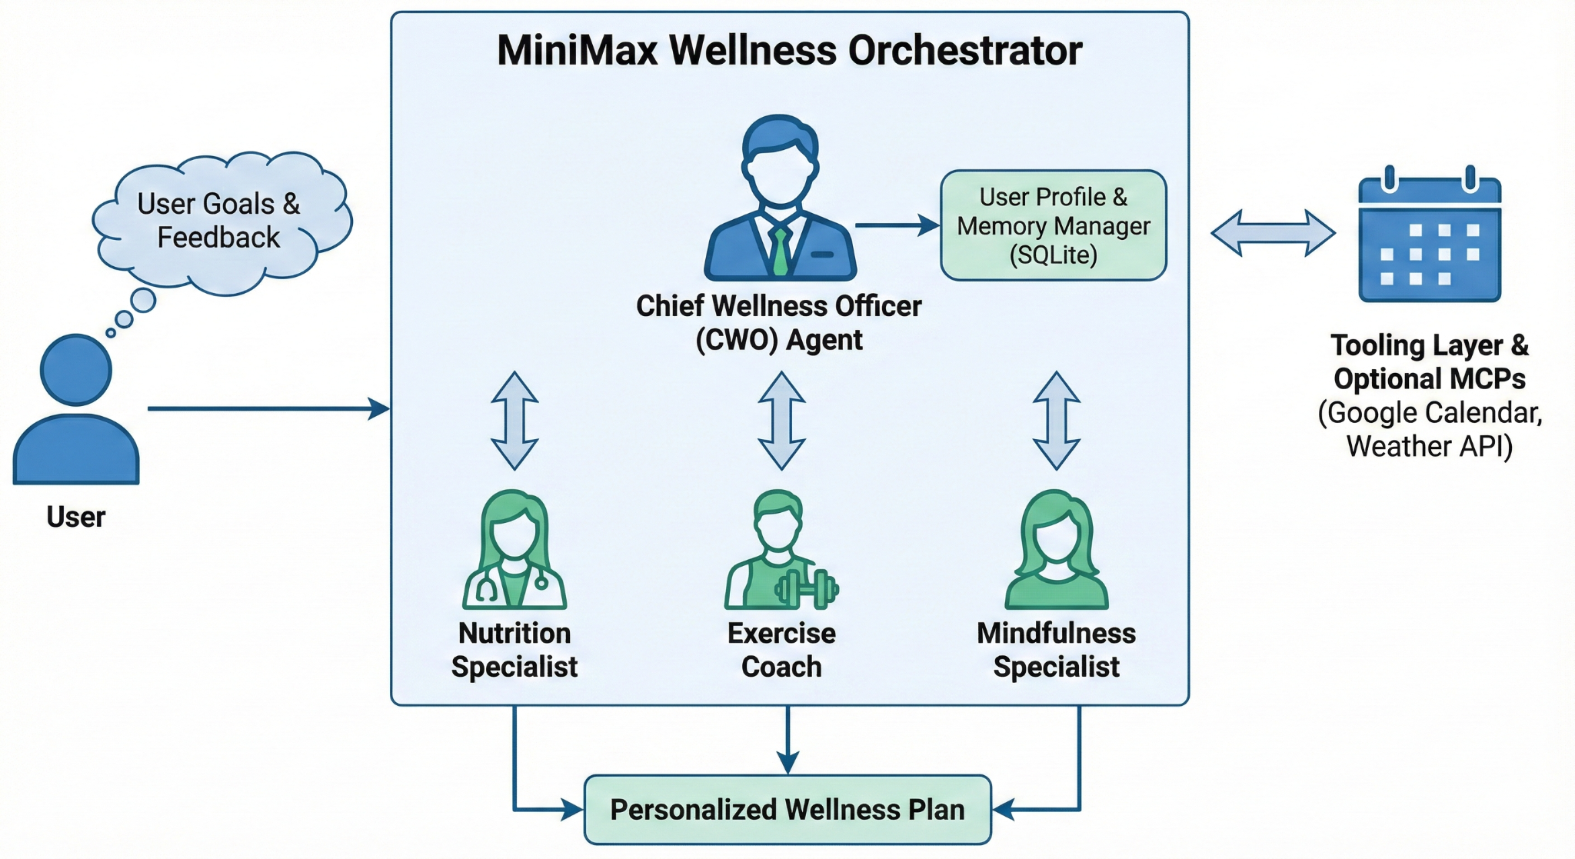

MiniMax is designed to demonstrate the capabilities of **agentic AI systems**: contextual reasoning, multi-agent coordination, adaptive planning, and ethical safeguards. The result is an intelligent, memory-aware assistant capable of delivering realistic and responsible wellness guidance tailored to each user’s needs.

# **Problem Statement**

Most wellness applications provide generic, one-size-fits-all advice that does not reflect an individual’s real health profile, preferences, or daily constraints. They lack the ability to **remember users across sessions**, cannot reason across multiple domains such as exercise, nutrition, and mindfulness, and often fail to adapt when users present **incomplete, conflicting, or medically sensitive information**.

The challenge addressed in this project is to build an AI system that can deliver **personalized, safe, and context-aware wellness plans** by combining:

* Multi-agent specialization
* Persistent user memory
* Structured tool-calling
* Safety-aware reasoning
* Adaptive, conversational planning

MiniMax aims to solve the limitations of traditional wellness tools by orchestrating multiple domain experts under a central agent, ensuring that every recommendation, workout, meal plan, or mindfulness exercise is tailored to the user’s goals, lifestyle, and health context while maintaining strict safety boundaries.

# **Solution Statement**

To address the need for personalized and context-aware wellness guidance, this project introduces **MiniMax**, a multi-agent wellness orchestrator powered by a central **Chief Wellness Officer (CWO)** agent. The CWO coordinates specialized agents for **exercise**, **nutrition**, and **mindfulness**, each contributing domain-specific reasoning to a shared context.

The system uses **persistent user profiles** and **long-term memory** to retain critical information such as age, dietary preferences, fitness level, goals, and past interactions allowing it to adapt recommendations over time. Through structured **tool-calling workflows**, each specialist retrieves relevant data, generates detailed outputs, and passes them back to the CWO for consolidation into a unified plan.

Safety is integrated throughout the solution. When user data indicates potential health risks, MiniMax adjusts its behavior by issuing medical advisories, limiting prescriptive content, and prioritizing wellness stabilization over goal-driven optimization.

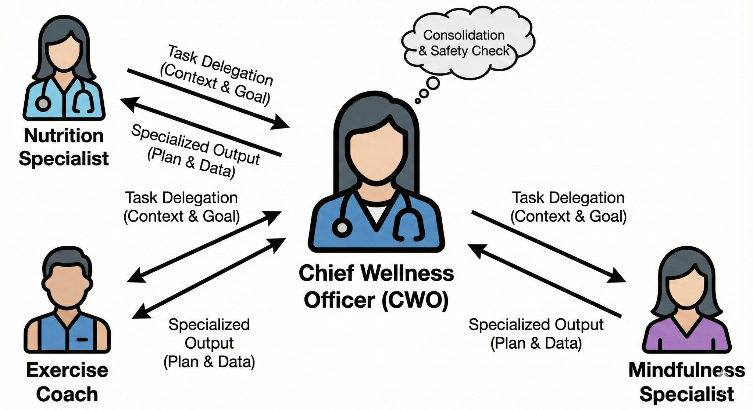

By combining multi-agent reasoning, memory, safety mechanisms, and modular tool integrations, MiniMax delivers a responsible, personalized, and scalable solution to comprehensive wellness planning.

# **Architecture**

This section describes the system architecture of **MiniMax — Wellness Orchestrator**, grounded strictly in your project code and docs. It explains the major components, how they interact, the data flows (including the shared_context pattern), memory design, MCP integration, and deployment considerations.

## **1. High-level architecture (overview)**

MiniMax is organized as a three-layer agent stack:

1. **Orchestration Layer** — **Chief Wellness Officer (CWO)**: conversational front-end and decision hub that manages session flow, handles clarifying questions, enforces safety rules, invokes specialists, and merges outputs. (cwo_agent.py).
2. **Specialist Layer** — domain agents that provide focused reasoning and structured outputs:  
   * **Nutrition Specialist** (nutrition_agent.py, nutrition_tools.py).
   * **Exercise Coach** (exercise_agent.py, exercise_tools.py).
   * **Mindfulness Specialist** (mindfulness_agent.py, mindfulness_tools.py).  
      Each specialist implements the common Agent interface and returns validated, structured content. (agent.py).
3. **Tooling & Persistence Layer** — profile store, memory manager, and MCP wrappers:  
   * user_profile_store.py (SQLite-backed profile persistence).
   * user_memory_manager.py / cwo_memory_tools.py (short- and long-term memory management).
   * MCP adapters and optional integrations (calendar, weather) with fallbacks.

This layered layout keeps specialist logic modular and the CWO lightweight and policy-driven.

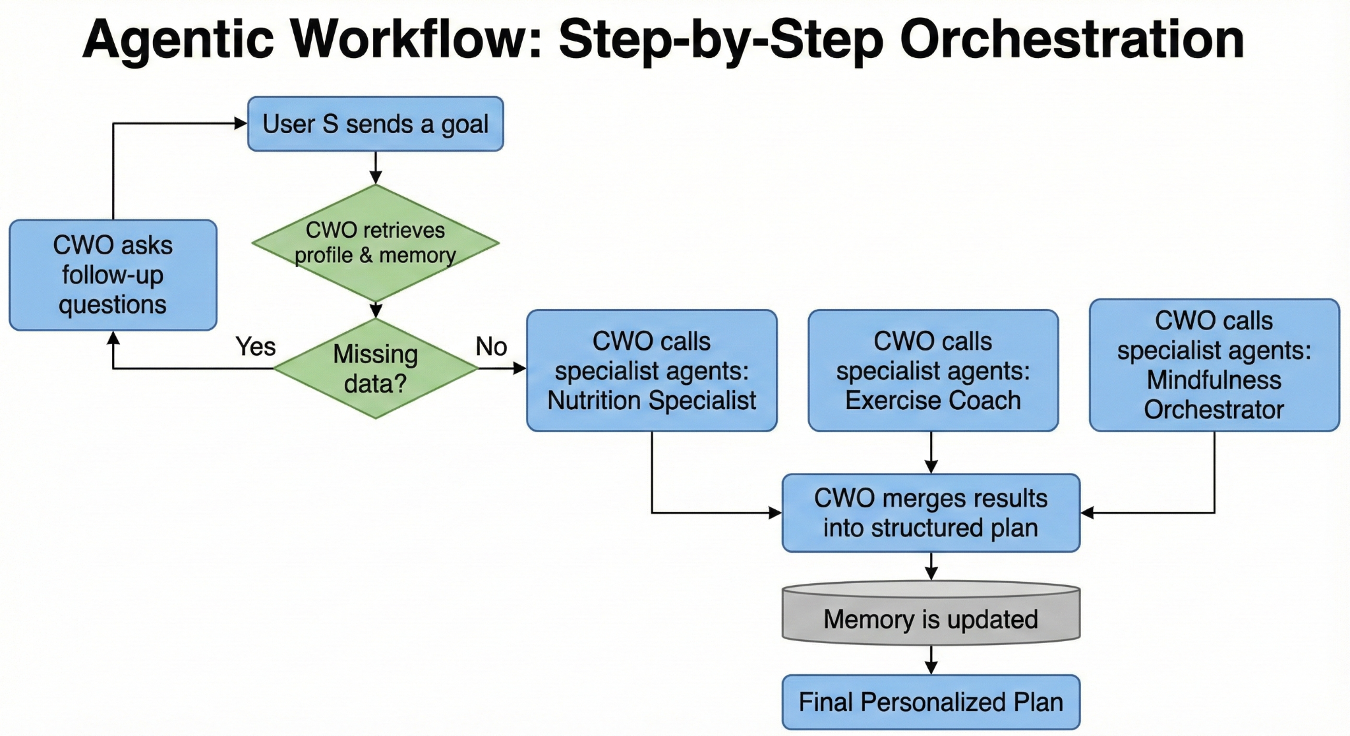

## **2. Component responsibilities**

* **CWO (cwo_agent.py)**
  + Accepts user input, retrieves user_profile and recent memories.
  + Runs safety checks (e.g., flagging dangerously low weight).
  + Generates follow-up questions if data is missing.
  + Calls specialist agents and merges their structured responses into a final plan.
  + Persists insights (remember_user_insight) and profile updates.
* **Agent Base (agent.py)**
  + Defines the standard interface: prompt construction, tool invocation helpers, output parsing, and error/fallback handling.
* **Nutrition / Exercise / Mindfulness Agents**
  + Each contains domain tools (e.g., calorie formulas, exercise selection rules, breathing scripts), validation, and safety filters. They return structured dicts (plans, warnings, suggested metrics).
* **Persistence & Memory**
  + user_profile_store.py: stores canonical profile fields (age, height, weight, gender, dietary prefs, fitness level, goals).
  + user_memory_manager.py / cwo_memory_tools.py: stores episodic/insight memories (previous goals, adverse reactions, preferences) that CWO consults to personalize responses.
* **MCP Integrations**
  + Optional adapters allow calendar and weather lookups to influence scheduling and indoor/outdoor decisions. Integrations have explicit setup steps and fallbacks to keep demos reproducible without API keys.

## **3. Shared context & orchestration pattern**

The system uses a shared_context enrichment pattern:

1. **Initialize:** CWO builds an initial shared_context with raw user input and retrieved profile + recent memories.
2. **Clarify:** If required fields are missing (e.g., height, daily availability), CWO asks short clarifying questions and updates the profile/memory.
3. **Specialist Calls:** CWO calls each specialist with the current shared_context. Specialists append their domain outputs (plans, constraints, warnings) to shared_context. Calls may be run in parallel or sequentially depending on dependencies (e.g., nutrition and exercise can run concurrently).
4. **Merge & Validate:** CWO consolidates specialist outputs, performs cross-checks (e.g., caloric plausibility vs. activity level), applies safety filters, and produces the final user-facing plan.
5. **Persist:** Key insights (name, preferences, adverse events) are written to memory/profile for future sessions.

This pattern ensures modularity (each agent focuses on its domain) while enabling multi-domain reasoning via the shared context.

## **4. Memory model**

* **Profile (long-lived, structured):** canonical user attributes stored in SQLite (age, height, weight, gender, dietary preferences, fitness level, goals, equipment availability). Used to seed planning and safety checks. (user_profile_store.py).
* **Insights / Episodic Memory:** time-stamped insights recorded via remember_user_insight — examples: “preferred indoor workouts,” “felt bad after breathing exercise,” “declined outdoor runs.” These inform future clarifications and safety escalations. (user_memory_manager.py, cwo_memory_tools.py).
* **Memory Access Pattern:** CWO loads recent memories at session start (load_user_memories), uses them for personalization, and stores new insights at session end. Memory is intentionally lightweight and focused on behaviorally relevant items (not raw conversation transcripts).

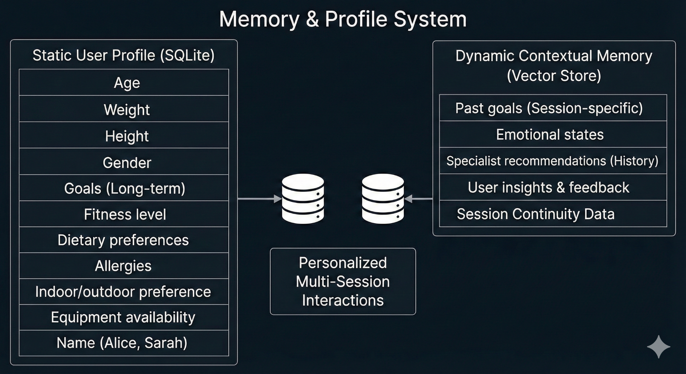

## **5. Safety & policy enforcement**

Safety is enforced at multiple points:

* **Input validation:** obvious impossible values or missing critical fields trigger clarifying questions.
* **Health signal detection:** if profile data indicates severe risk (e.g., BMI far below expected range), CWO issues strong medical advisories and limits prescriptive outputs (e.g., moves from weight-loss plans to nourishing/wellness-first guidance). This is demonstrated in your terminal logs.
* **Adverse event handling:** if the user reports feeling worse after an exercise or mindfulness practice, the agent escalates: empathetic response + advice to seek immediate medical attention and suspension of prescriptive plans until cleared.
* **Tool-level constraints:** specialists validate generated items (exercise intensity checks, calorie plausibility) before passing to the CWO.

## **6. Deployment & runtime notes**

* **Execution modes:** CLI Direct Mode (for demos) and optional FastAPI server mode for integrations. Quickstart and README document both.
* **Dependencies:** listed in requirements.txt (notable: google-adk, vertexai, web server libs). Ensure Vertex/ADK credentials for cloud model use; local demos run with minimal configuration (No-MCP).
* **Performance:** typical specialist orchestration times vary (short memory ops ~0.5–1s; full specialist synthesis 6–40s; long-form mindfulness generation may be longer). Consider streaming or parallelization for UX improvements.

## **7. Files of interest (where the architecture is implemented)**

* Architecture & design: ARCHITECTURE.md.
* Orchestrator: cwo_agent.py.
* Agent interface: agent.py.
* Specialists: exercise_agent.py, nutrition_agent.py, mindfulness_agent.py and their *_tools.py.
* Persistence & memory: user_profile_store.py, user_memory_manager.py, cwo_memory_tools.py.
* MCP docs & setup: MCP_INTEGRATION.md, MCP_SETUP.md.
* Quickstart: QUICKSTART.md; repo overview and reproducibility: README.md.

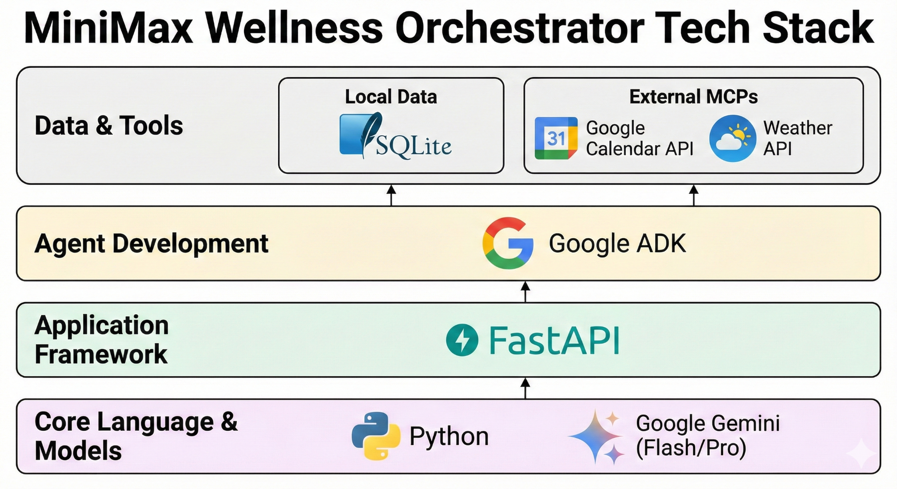

# **Conclusion**

MiniMax demonstrates how a multi-agent, memory-driven architecture can deliver personalized, safe, and context-aware wellness guidance across exercise, nutrition, and mindfulness. By combining a central orchestrator (CWO) with domain-specialist agents and persistent user profiles, the system adapts its recommendations to each user’s goals, preferences, and health context even across multiple sessions.

A key strength of the solution is its **safety-first behavior**. When users provide risky or medically sensitive information, the system automatically shifts into protective mode, limits prescriptive guidance, and issues clear medical advisories. This ensures that personalization never compromises user safety.

Through structured tool-calling, shared context reasoning, and optional MCP integrations, MiniMax showcases the practical value of agentic AI systems in real-world wellness planning. The project highlights how modular agents, persistent memory, and ethical safeguards can be combined to create a reliable, extensible, and user-centric assistant.

# **Value Statement**

MiniMax delivers meaningful value by transforming wellness guidance into a **personalized, adaptive, and safety-aware experience**. Instead of generic recommendations, users receive plans shaped by their real profile, preferences, environment, and behavioral history—thanks to persistent memory and multi-agent specialization.

By orchestrating nutrition, exercise, and mindfulness expertise through a central agent, MiniMax provides **holistic, coherent, and contextually aligned** wellness plans that evolve with the user over time. Its built-in safety mechanisms ensure that users with health risks receive appropriate caution and non-prescriptive support, reinforcing trust and responsibility.

The result is a wellness assistant that is not only more **intelligent and helpful**, but also more **ethical, reliable, and user-centric**—demonstrating the practical strengths of agentic AI systems in real-world personal health applications.

##### 

# **Project Links**

<https://github.com/vishalwankhede44/google_capstone_project>

# 